Instructions for converting the handles – ‘Old to New’ version:
Old version New version
Figure 1 Figure 2
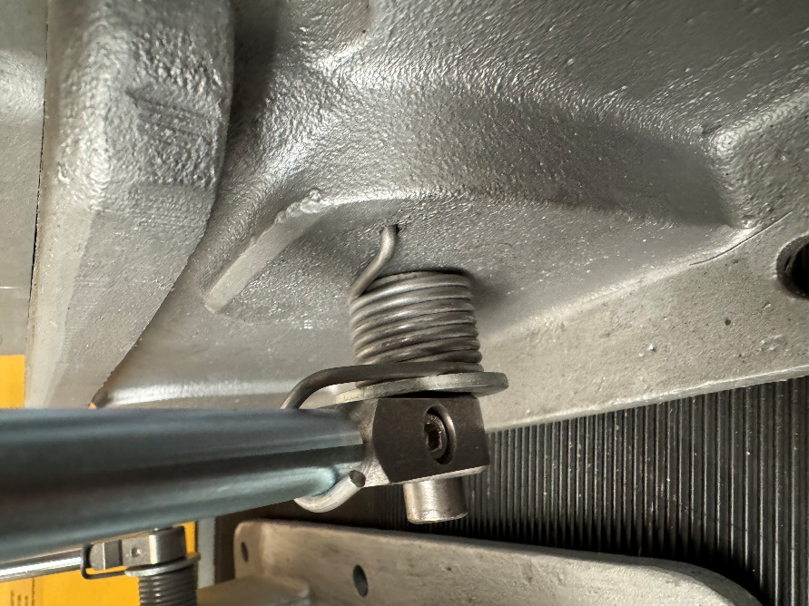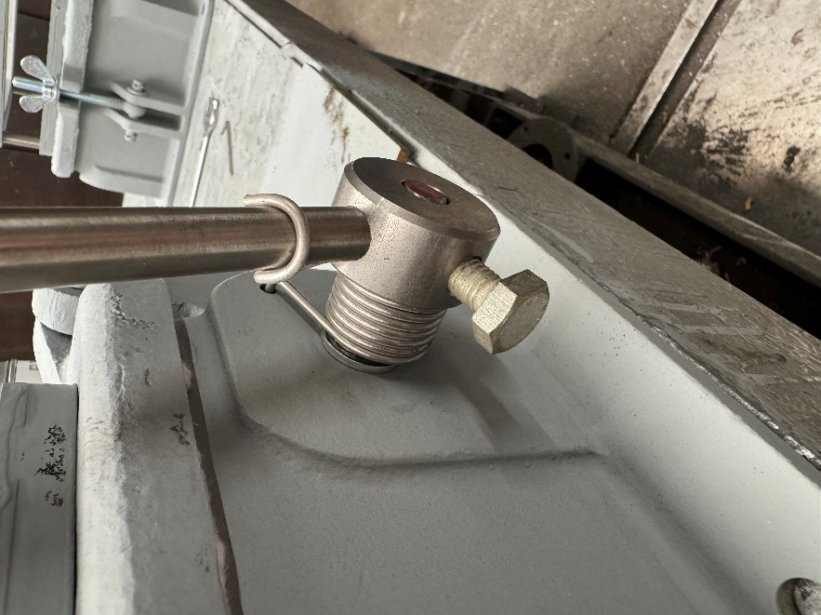
Figure 3 Figure 4
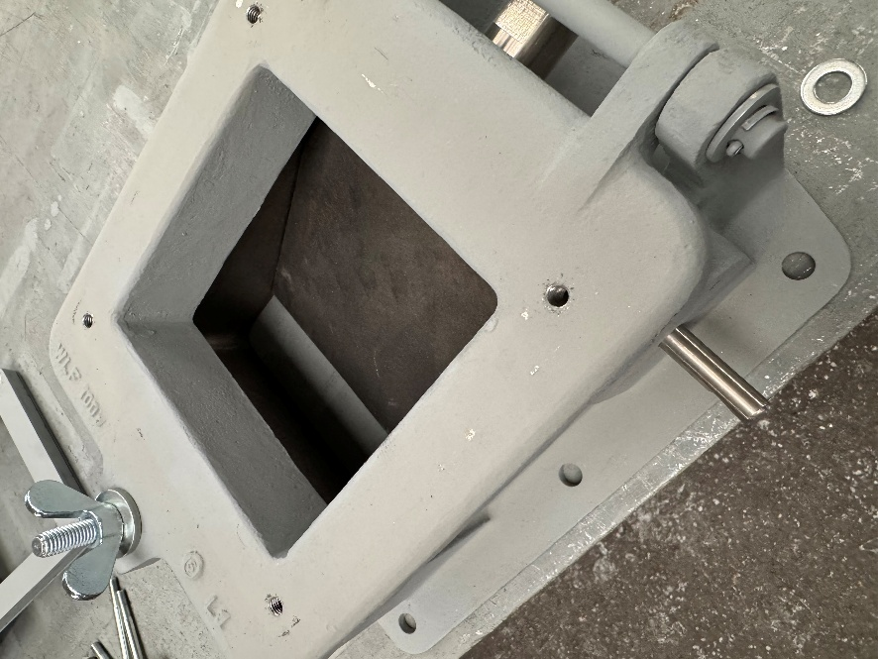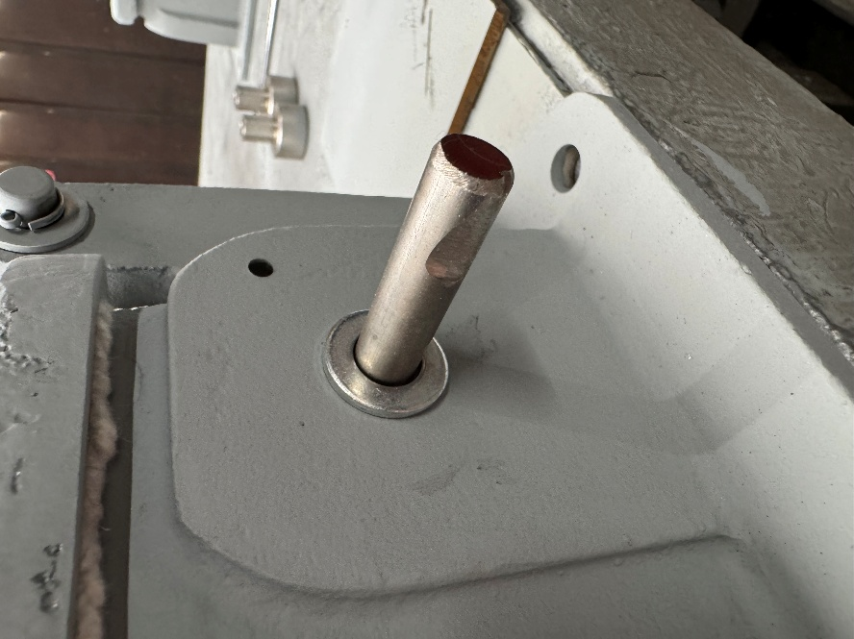
- When replacing the handles, the inspection hatch must be placed on a level surface.
- First, remove the old handle. The flap should then rest on the table whilst you continue with the preparation (arrow, Figure 3), so that the clamping surface for the clamping screw can be fitted (arrow, Figure 4).

Figure 5 Figure 6
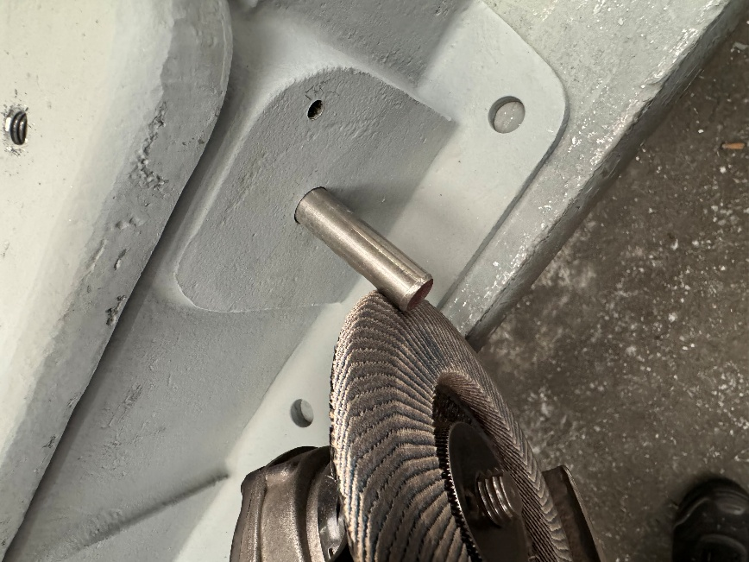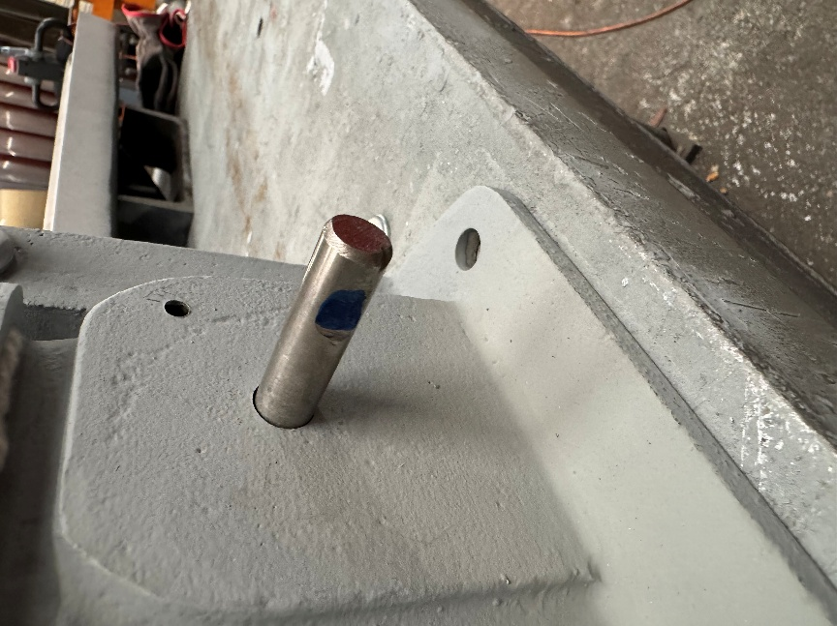

Figure 7 Figure 8 Figure 9
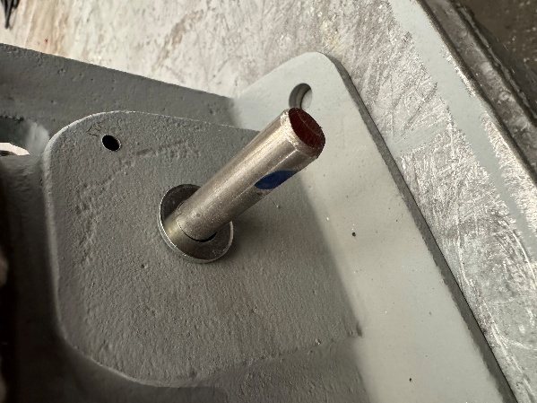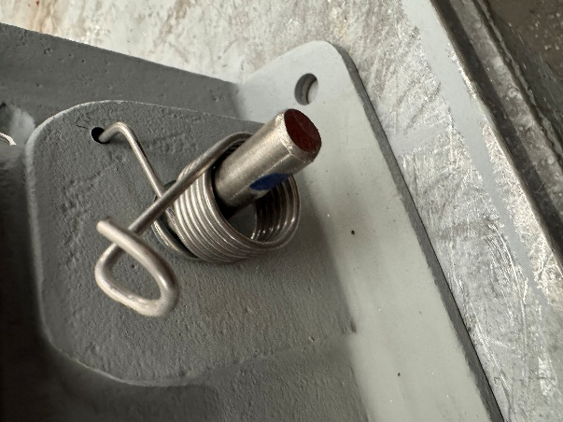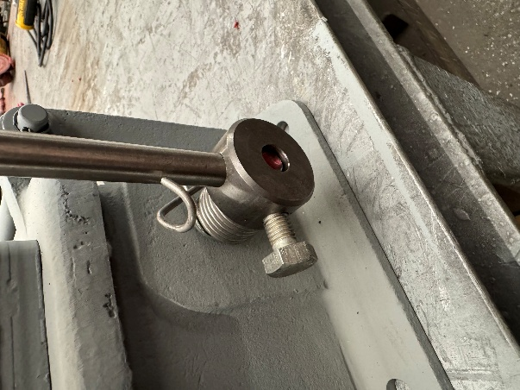
- Use the grinder to create a small flat surface on the shaft at a 90° angle (Figures 5 and 6)
- Fit washer A13 (Figure 7)
- Fit the return spring (Figure 8)
- Fit the new handle (Figure 9)

figure 10 Figure 11
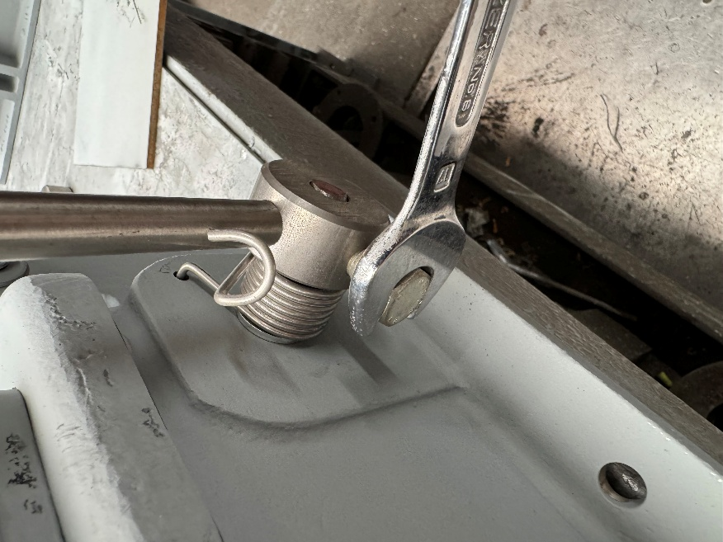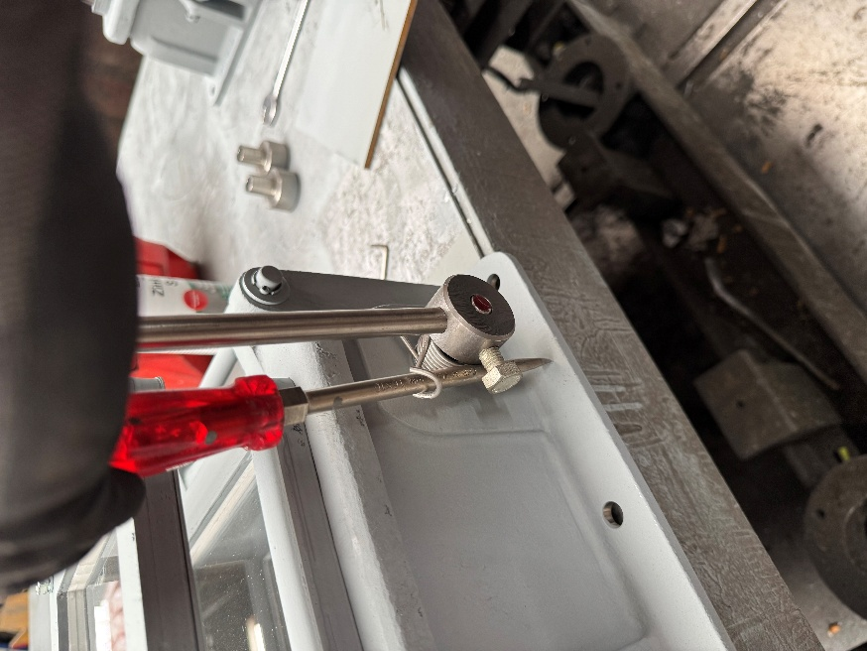
- Screw the handle in place so that the screw presses against the flattened area, then tighten.
- Next, position a large screwdriver as shown in Figure 11 to tension the spring.
- Turn the screwdriver 180 degrees anti-clockwise (Figures 12–17)
Figure 12 Figure 13
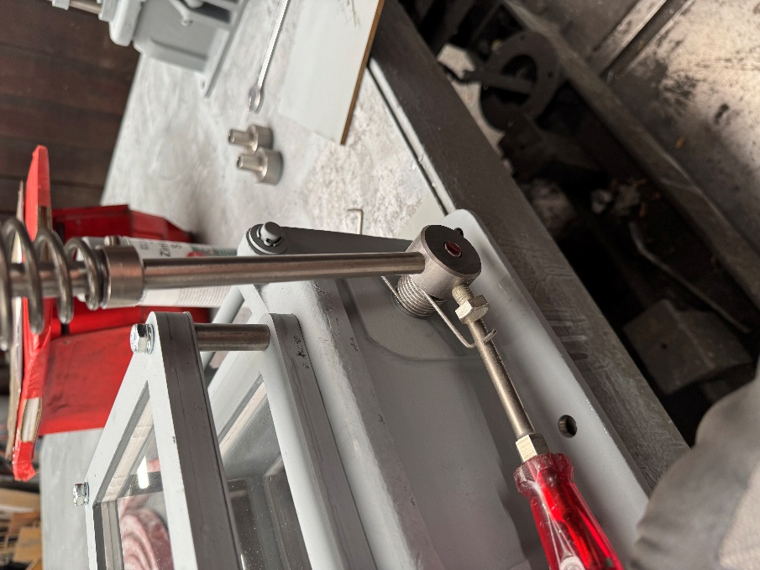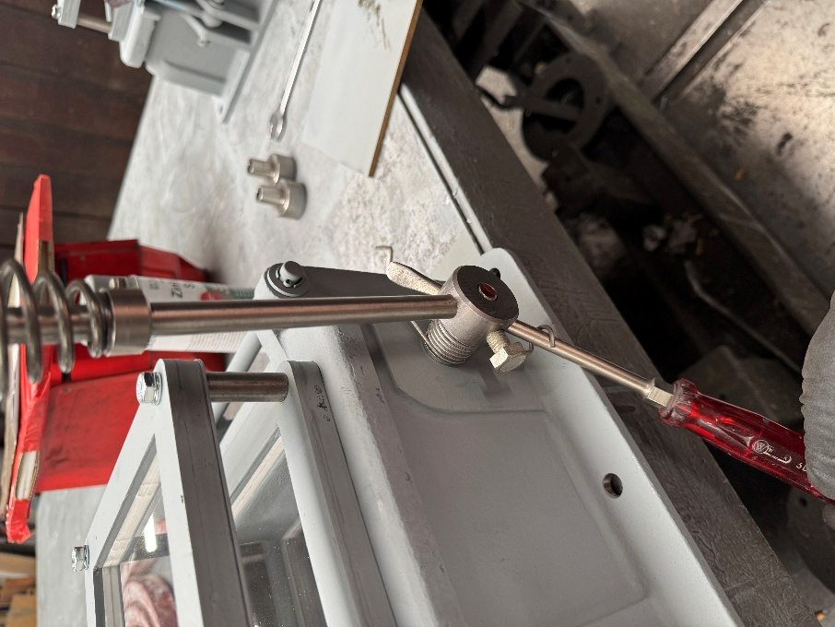
Turn………………………………………………………………..turn more………………………………………………….
- Turn the screwdriver 180 degrees anti-clockwise (Figures 12–17)
Figure 14 Figure 15
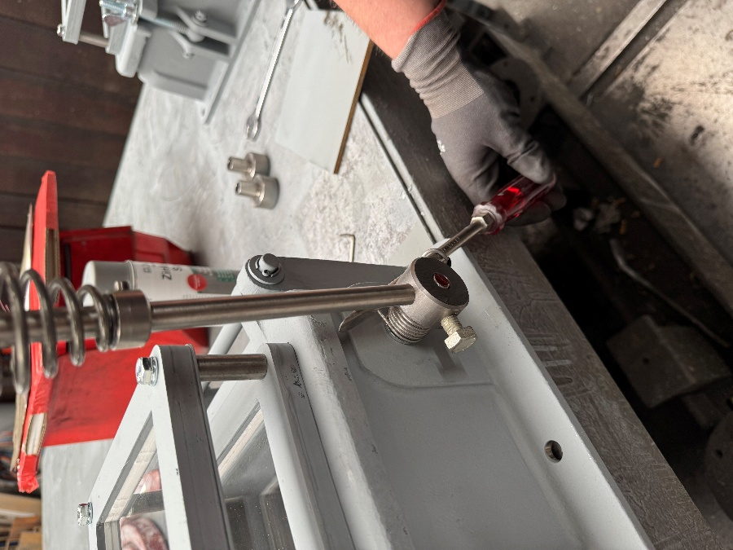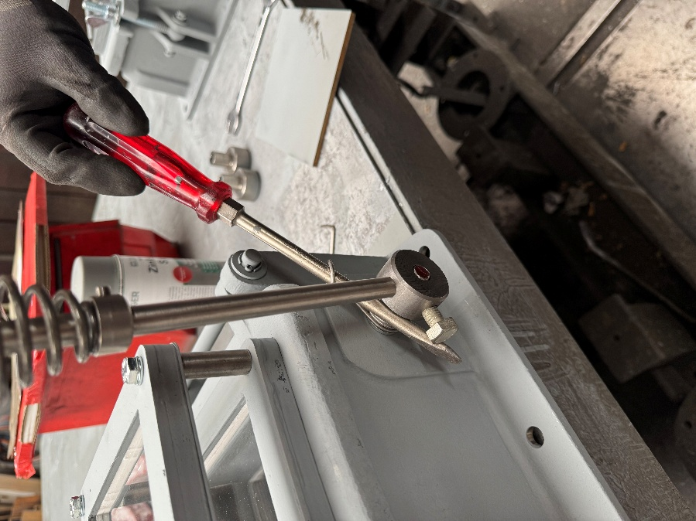
turn it a little further ……………………………………..just a little bit more ….…………………………………

Figure 16 Figure 17
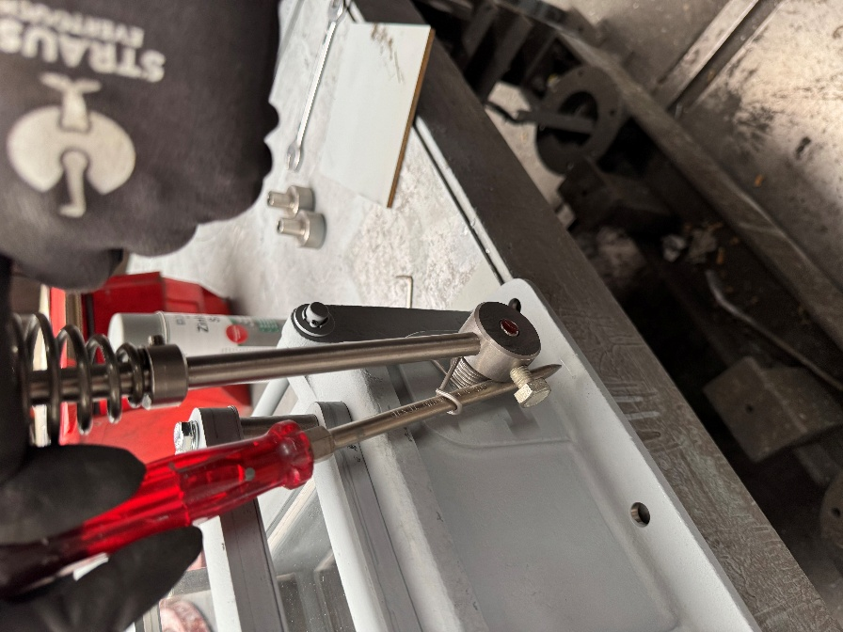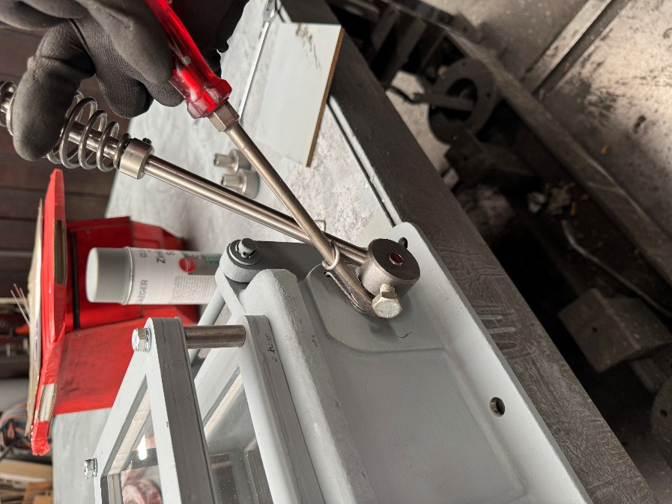

STOP
Stop!!! Do not turn any further now!!! Once the 180° position has been reached after one full turn, pull the screwdriver gently forwards to allow the spring’s hook to snap into place on the handle bar. Simply pull the screwdriver out and the return spring will be tensioned (as shown in Figure 2).

